LIGHT DOSE QUESTIONS

STEP BY STEP solving process.

1.Initiailly I installed git and libreoffice in my ubuntu termial.

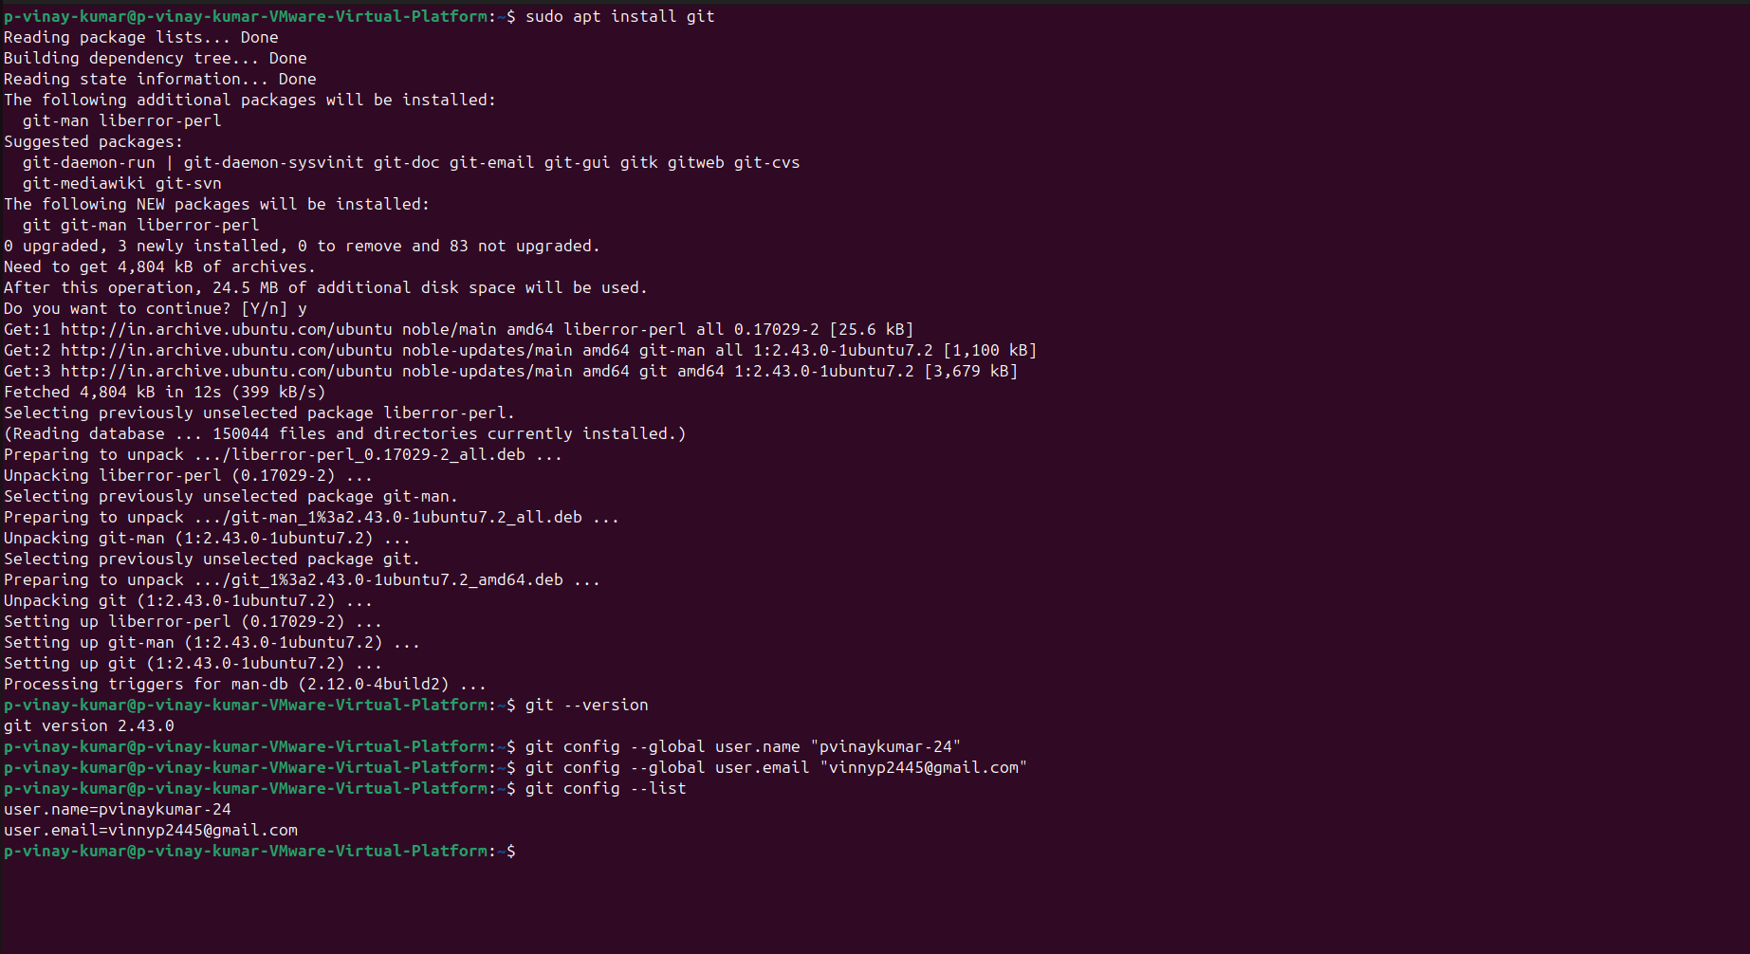

2. I created a github account and cloned it with terminal.

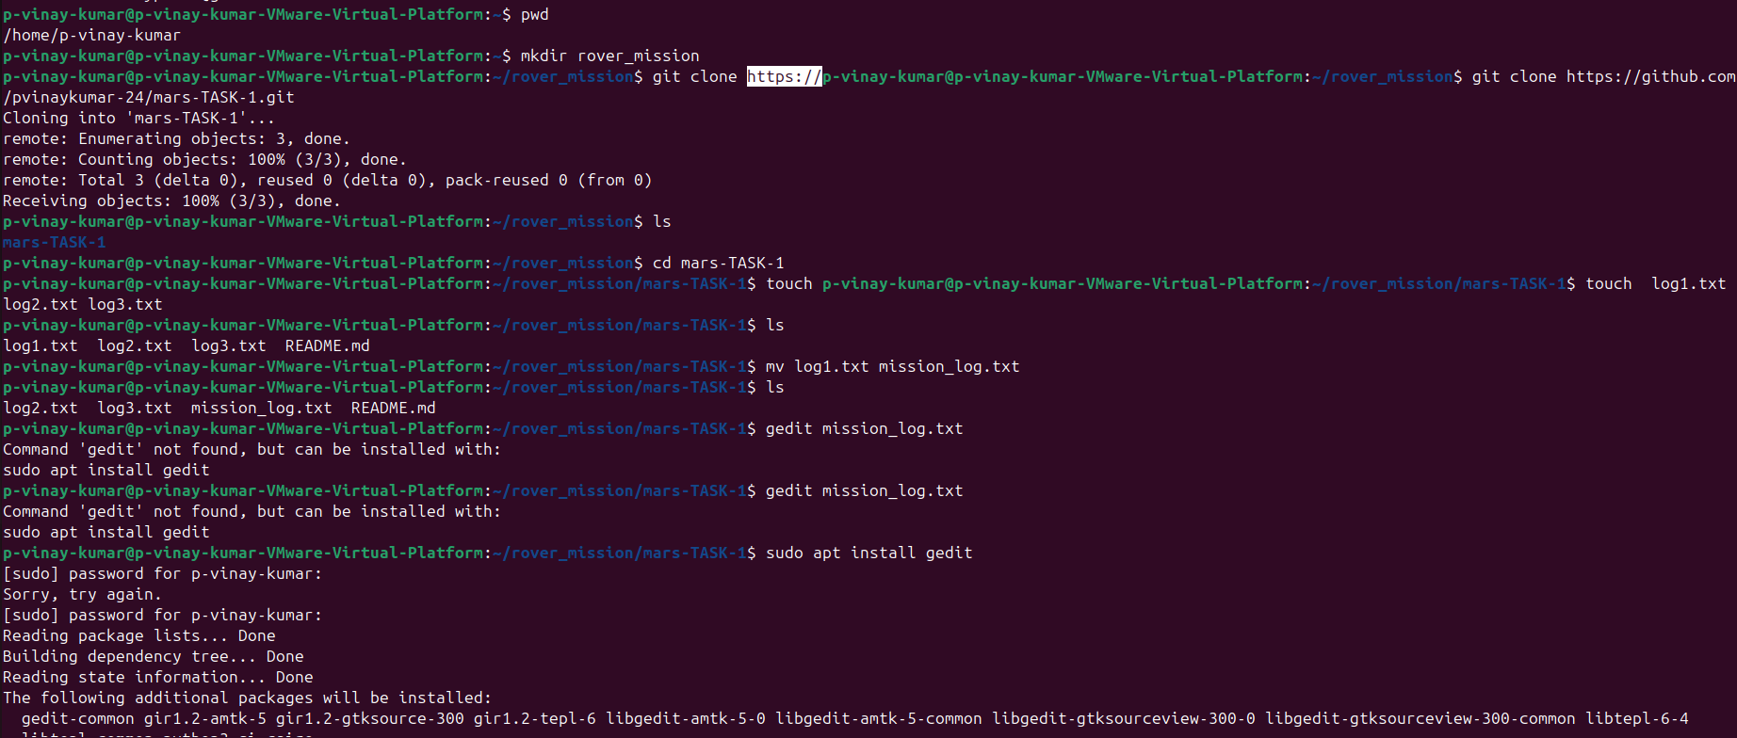

3. Now actual question starts , simple execution of commands in terminal

like creating the directories and files in that,renaming it, and lot more.

HERE is my work.

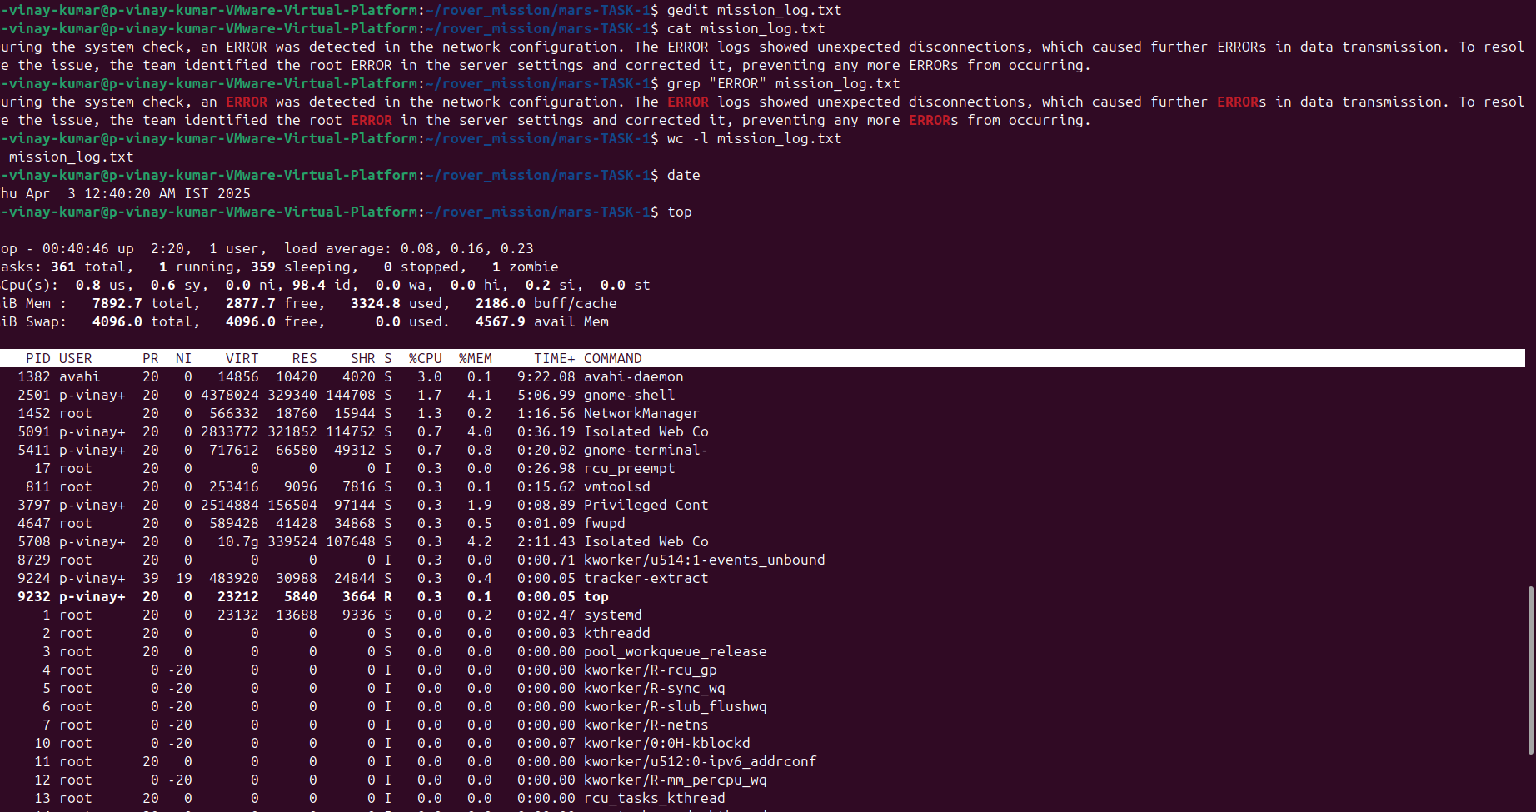

4.After executing all the commands I need to push this file to github so I performed this task, by pushing (mission_log.txt,log2.txt,lo3.txt)files into github repository,

HERE is the pic of that.

I got some issues at first..

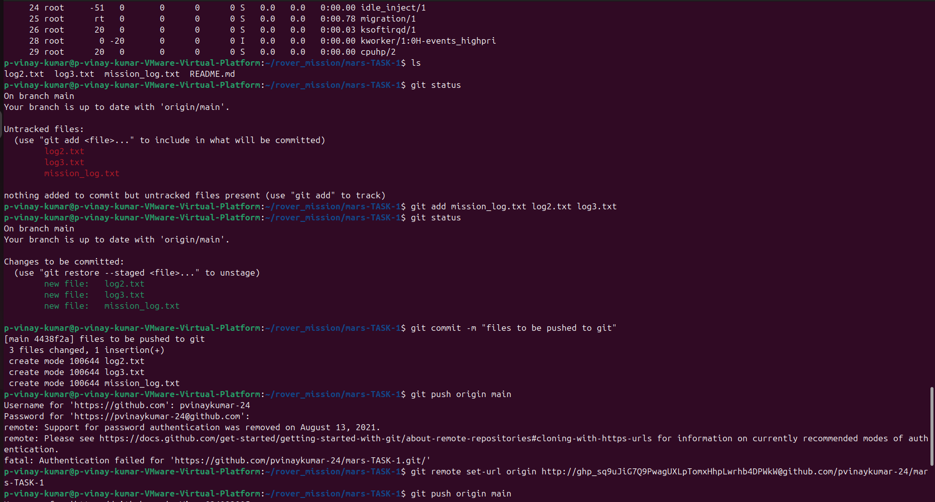

Finally I pushed files into github repository.using access tokens for authentication.

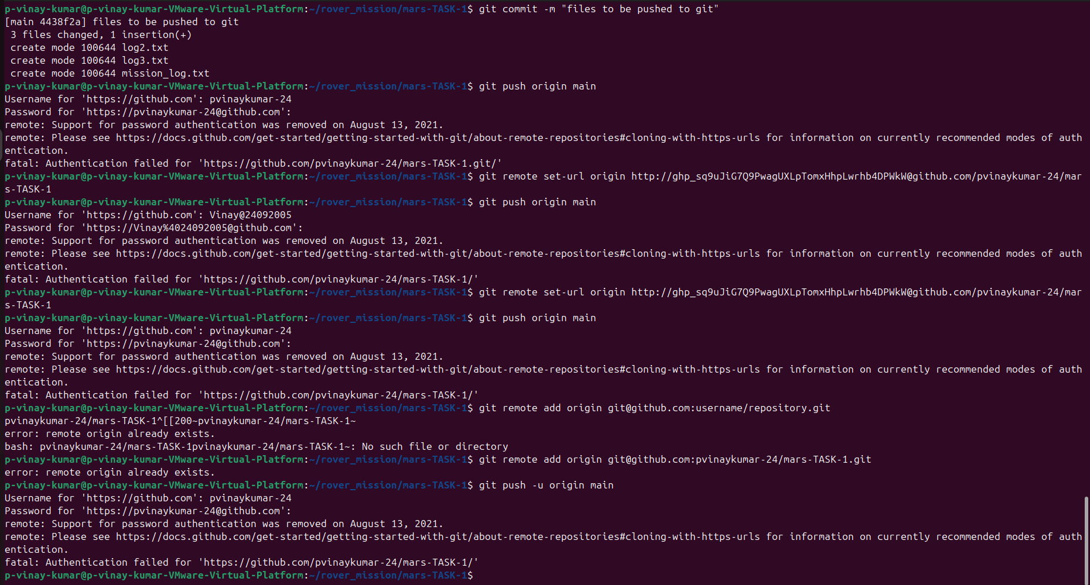

2 problem using BASH script.

1)Write a Bash script rover_system_check.sh that performs a pre-mission check for the rover. First, generate a random battery percentage (0-100). If it’s below 20%, log "Battery low! Return to base!" and exit. Next, ping google.com to check network connectivity. If the ping fails, log "Communication failure!" and exit. If both checks pass, log "All systems operational!"

solution: code for problem in BASH.

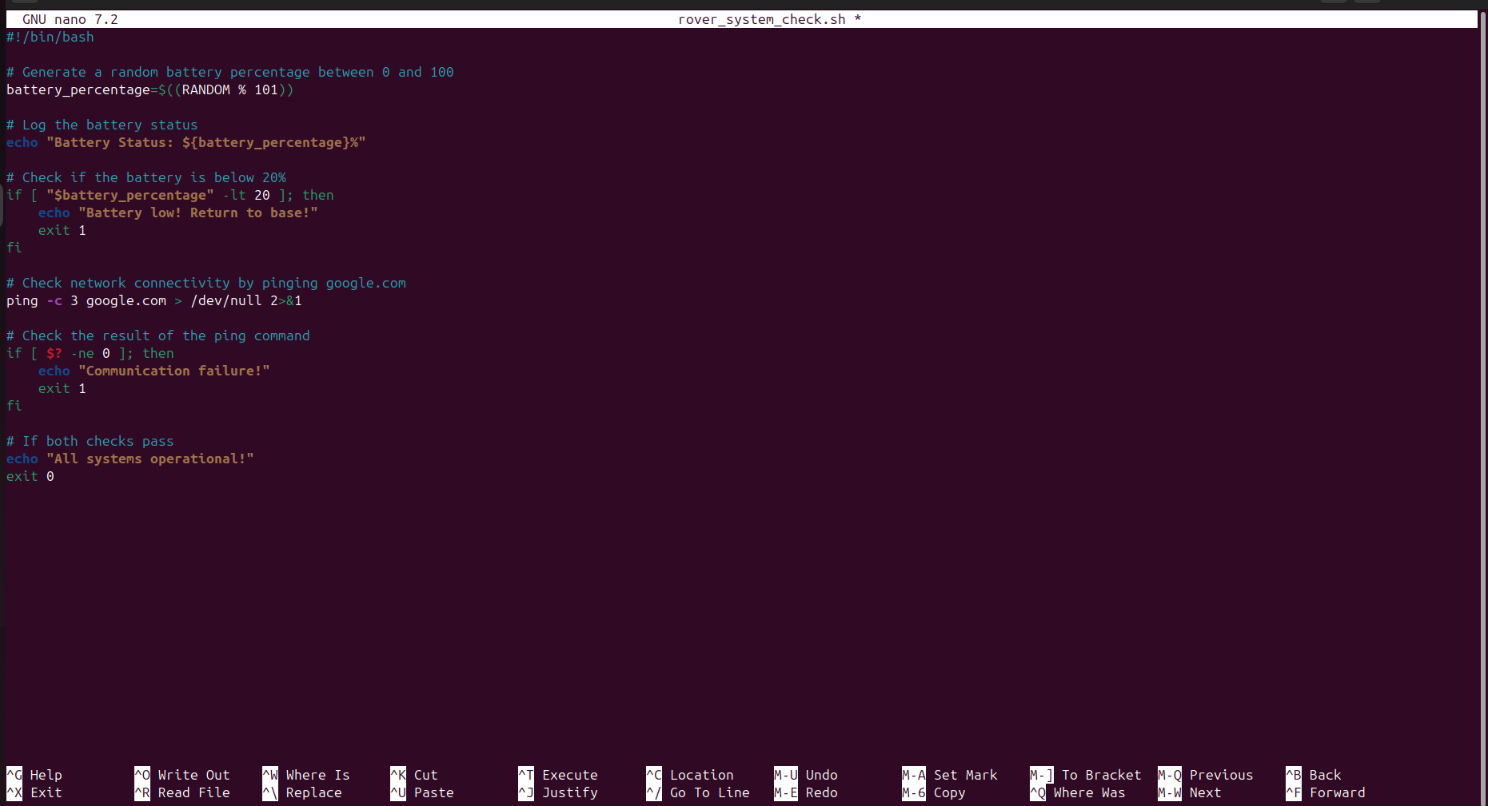

Output:

